Risk Assessment [TEMPLATE] Guidance

Text from the Lewisham Council Form. Adapt as required –
The purpose of this guidance is to assist anyone with managerial responsibility in carrying out the Health and Safety risk assessments for which they are responsible in accordance with the requirements of the Management of Health and Safety at Work Regulations 1999 which underpins the Health and Safety at Work etc. Act 1974.

Assessment Subject
This section must describe the work activity or task being risk assessed. For example: undertaking home visits alone, use of a playground, driving a refuse truck, holding a public meeting, etc.

Date of Assessment
This is the date the assessment is signed off.

Review Date
This is the date for the next review of the assessment. The risk assessment should be reviewed regularly to ensure that the risk of staff being harmed has not changed and that no further control measures are needed. It is recommended to review the risk assessment annually, and no less than every 3 years. It should also be reviewed if any changes occur that may increase the risk of harm.

Hazard(s) Identified:
This section must include only the hazards associated with the activity or task being risk assessed. A hazard is anything with the potential to cause harm. For example, the physical environment (such as tools and equipment, furniture, cars/vehicles etc.), and the situation staff may be in (such as working alone, confronting people, etc.)

What is the risk? Who and how are they affected?
This section must include the risks (the consequences) of the hazard. For each risk, the person(s) at risk and potential harm to them should also be identified. For example, a member of staff working alone may be subject to verbal abuse causing them stress; a refuse truck driver may be involved in a collision with another vehicle – causing death to both drivers; a service user may trip and fall due to a frayed carpet leading to serious injuries, a carer may be moving equipment or a person and sustain a back injury, a contractor working on a Council building is exposed to asbestos, etc.

Existing Control Measures
Control measures are the arrangements made or precautions taken to reduce the risks identified. For example, training provided (such as managing violence and aggression or manual handling) to help staff cope with difficult situations/tasks, maintenance of vehicles/equipment to ensure it is in good working order, routine inspections (such as of the fabric of Council buildings) to identify potential problems early, regular discussion of Health and Safety matters (with staff and contractors) to ensure Health and Safety awareness is maintained, use the hierarchy of control.

The Hierarchy of Control
The levels down the hierarchy state the ways to control the hazard if it cannot be removed or eliminated.
The hierarchy of control is:

1. Elimination – Redesign the job or substitute a substance so that the hazard is removed or eliminated.
2. Substitution – Replace the material or process with a less hazardous one.
3. Engineering controls – Use work equipment or other measures to prevent falls where you cannot avoid working at height.
4. Administrative controls – These are all about identifying and implementing the procedures you need to work safely.
5. Personal Protective Equipment (PPE) – Only after all the previous measures have been tried and found ineffective in controlling risks to a reasonably practicable level, must personal protective equipment (PPE) be used.

Monitoring is required to ensure that the controls are operated as designed.

Risk Rating (severity of harm x likelihood of exposure = risk)

Risk is the likelihood that a hazard will cause actual harm. The likelihood is a measure of the potential frequency with which the risk occurs. The severity of harm is a measure of the level of injury, damage or loss should a risk occur.
These concepts of severity and likelihood are illustrated further in the tables below.

Table 1 – Explains how to rate a severity of a hazard by numerical value and the corresponding categories of the severity of harm.
Table 2 – Explains how to rate the likelihood of a hazard by numerical value and the corresponding categories for the likelihood of exposure.
Table 3 – Shows how the two scores for severity and likelihood are combined to calculate an overall risk rating which is then ranked as with Very High, High, Medium or Low. Gives the overall numerical value for the likelihood and the severity of harm. It is used for calculating the risk rating and also deciding the level of risk for each hazard. For example, a hazard for lone working with the risk of verbal abuse could equal a likelihood of two (2) and a severity of two (2), which equals to four (4). That is; (2x2 = 4). This gives it a medium risk.
Table 4 – Gives information which should be used to determine the control measures and action required for managing the overall risk for each hazard identified.

Table 1. – Severity of Harm

3.12 Rating of hazard and corresponding numerical value | Severity of Harm
Low = 1 | Hazard resulting in minor injury requiring first aid treatment only. Minor potential loss consequence to individual and Lewisham Council.  Examples are minor cuts and bruises, eye irritation from dust, nuisance and irritation etc.
Medium = 2 | Hazard capable of resulting in personal injury/illness requiring absence from work. Medical attention required.  Medium is also any hazard that cannot be classified as neither high nor low
High = 3 | Serious consequential loss to an individual or Lewisham Council. A protracted period off work for many months.  Examples include, but not limited to fractures, lacerations, burns, concussion, serious sprains, dermatitis, asthma, work related upper limb disorders.
Very High = 4 | Major consequential loss to an individual or Lewisham Council. A protracted period off work or a limiting condition.  Examples include, but not limited to deafness, amputations, major fractures, poisonings, multiple injuries, fatal injuries, occupational cancer and other life shortening diseases.

Table 2. Likelihood of Hazard
Rating and corresponding numerical value | Likelihood of exposure
Unlikely = 1 | May occur in time, however hazard exists infrequently, or hazardous event occurs very infrequently.
Possibly = 2 | May occur occasionally. It is not Low or High
Likely = 3 | Hazard events occur frequently.
Very Likely = 4 | Hazards exists permanently relative to the activity/task being undertaken

Table 3. The Risk Rating/Severity
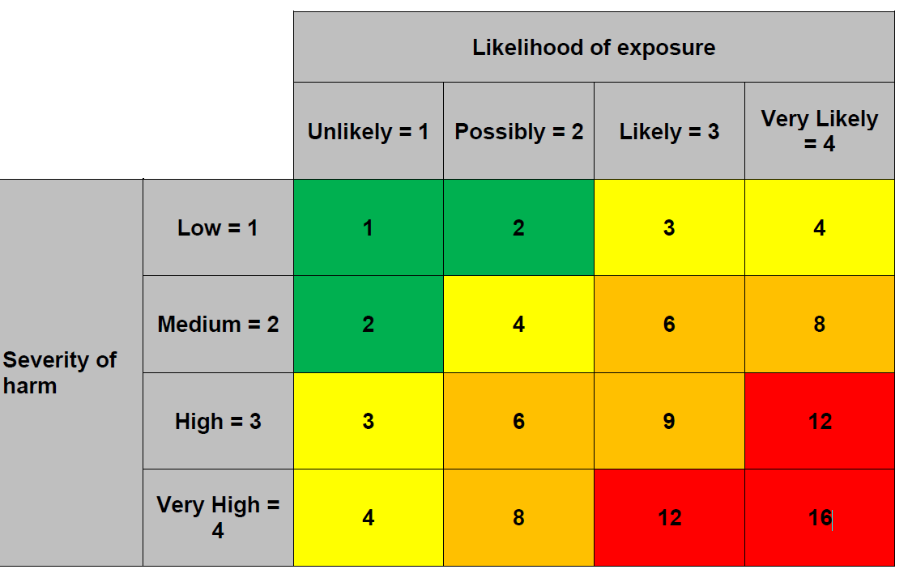
Table 4: Risk Based Action and Control
Risk Rating | Action and Timescales
LOW  1 – 2 | Minimal additional controls are required. Consideration may be given to a more cost-effective solution or improvement that imposes no additional burden. Monitoring is required to ensure that the controls are operated as designed.
MEDIUM  3 – 5 | Efforts should be made to reduce the risk, but the costs of prevention should be carefully measured and limited. Once agreed risk reduction measures should be implemented within a defined time period. Monitoring is required to ensure that the existing controls are operated as designed.
HIGH  6 – 9 | Where the risk is high, risk reduction measures must be implemented within a defined timescale. Regular monitoring is required to ensure that the implemented controls are working well and if any further control measures are required.
Very High  16 | Where the risk is very high, immediate risk reduction measures must be implemented within a defined timescale. The process of hierarchy of control must be applied, where the first control in the hierarchy is to remove or avoid the hazard completely.

