**Neighbourhoods – what do we know?**

**Neighbourhood Groupings:**

Lewisham Council teams have been moving towards a place-based approach for a number of years. Adult Health and Social Care operate their Integrated Neighbourhood Teams (INTs) within a 4-neighbourhood structure which is based on their Primary Care Networks. In the Children and Young People’s Directorate (CYP), Family Hubs and Youth Services also operate on a neighbourhood basis.

Although there are some small boundary crossovers, the neighbourhoods in both cases broadly fall into North, South, East and West areas.

In terms of the Main Grants monitoring, the neighbourhoods reflect the broader footprints of both the INT and CYP neighbourhoods but have been adapted slightly to ensure areas with similar demographics and similar needs are together.

The knowledge gleaned from the Local Assemblies and NCIL programmes have also helped to inform the groupings, as both programmes took a ward-based approach, but required clustered working in some areas - for example, Bellingham has been incorporated into the South of the borough alongside Downham to support existing work across the VCS in those areas due to similar demographic data and levels of deprivation.

The tables below show the groupings of the wards:

Ideally, monitoring data will need to be captured by funded organisations at postcode level to ensure it can be used effectively in all possible groupings.

**Lewisham Data**

Extensive data is available via the links on Lewisham’s Community Funding website on the [Local, London-wide and national data resources](https://communityfunding.lewisham.gov.uk/grant-support-hub/local-london-wide-and-national-data-resources) page. This includes the Lewisham Observatory which pulls together data from a range of sources and provides data on Lewisham’s population, Deprivation, Crime and Community Safety, Housing and Economy and Employment which can be filtered by ward.

In addition, you can find useful documents in the [report and strategy document library](https://communityfunding.lewisham.gov.uk/grant-support-hub/report-and-strategy-document-library).

**Integrated Neighbourhood Team data:**

Additional data available to us from the Integrated Neighbourhood Teams show:

The population and registered patients in each INT neighbourhood:

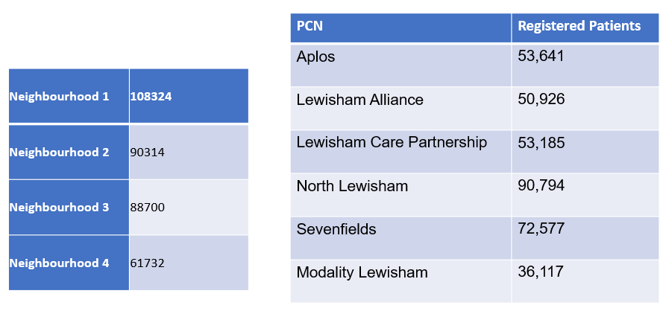

The current priorities for each of the Lewisham INT Neighbourhoods:

**Family Hubs data**

The following information is extracted from the Family Hubs Needs Assessment and from the

[Family Hubs Equalities Analysis Assessment](https://lewisham.moderngov.co.uk/mgConvert2PDF.aspx?ID=115548) which was written as proposals for Family Hubs were developed.

Family Hub Areas map:

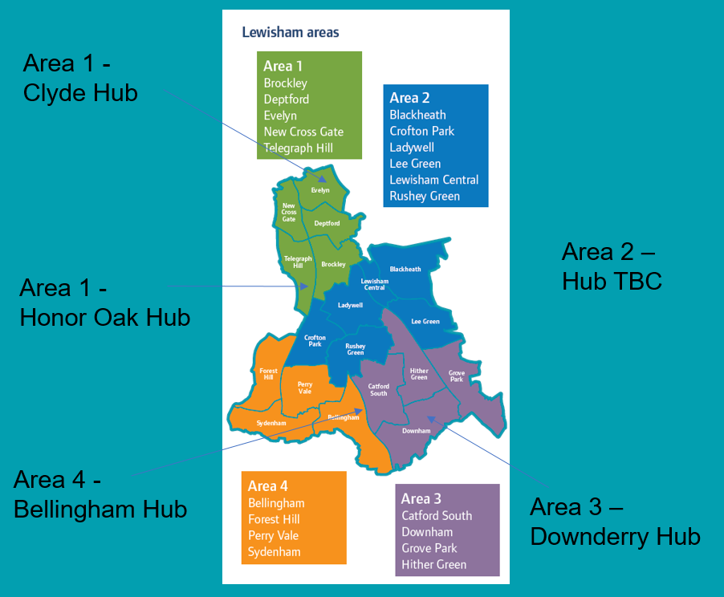

Data across areas:

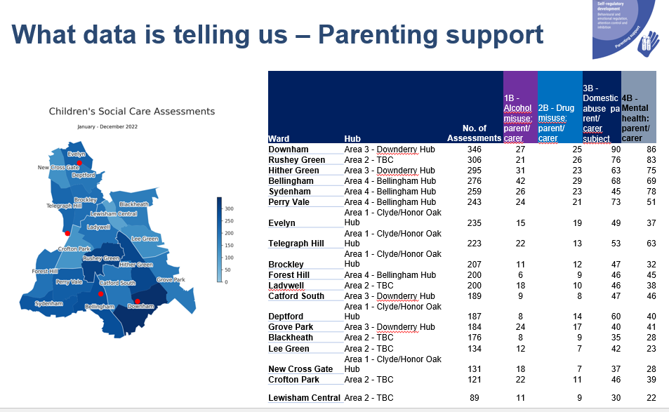

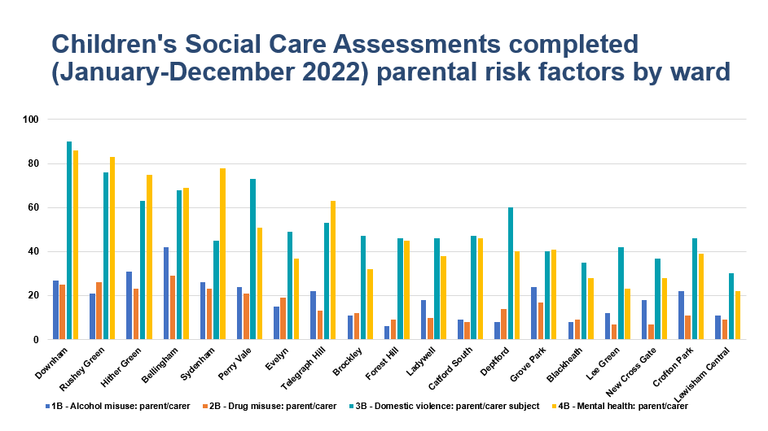

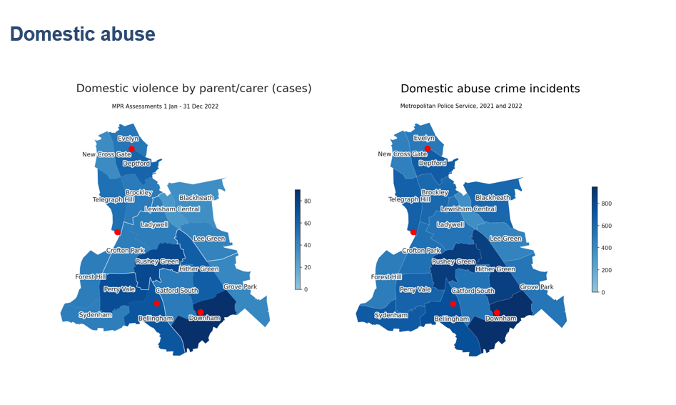

What Conclusions can be drawn from this?

* **Spatial inequalities** -- different needs in different parts of the Borough. Bellingham ward and other wards in Area 3 and 4 face an accumulation of pressures.
* **Infant feeding** – the risk factors tell us that children that are not breast-fed can become more obese.   For Family Hub services this means that in areas with high levels of obesity we need to raise awareness of the positive affect of breast-feeding, and support parents with healthy eating for their children to reduce levels of obesity
* **Perinatal mental health** – Increased mental health pressures in the South (Areas 2, 3, 4). This coincides with increased alcohol and drug use, as well as high deprivation.
* **Early language and home learning environment** – Most overcrowding is in the urban North (Area 1), while pupils attending Lewisham settings with Special Educational Needs are more prevalent in the suburban South (Area 3.)
* **Parenting support** -- Social Care Assessments are more common in the South (Areas 2, 3, 4).  We need to target parenting support in areas with high assessments such as Downham, Rushey Green, Hither Green and Bellingham.
* Population Distribution – Under 18 population overall is highest in Hub Area 2 where Family Hub site is still TBC. Highest 0-4 populations in Hither Green, Rushey Green, Perry Vale; Older teenage population more concentrated in Downham and Catford South.

**Other key findings:**

* Pupils with Special Educational Needs (SEN) - Prevalence of pupils attending Lewisham settings with Educational, Health and Care Plans is highest in the South of the Borough in Downham, Bellingham, Hither Green
* Pupils in receipt of Free School Meals (FSM) - Prevalence of pupils attending Lewisham settings with FSM is highest in Downham and Deptford
* Domestic abuse risk and mental health risks for parents/carers (linked to Assessments completed) highest in Downham, Rushey Green areas; Alcohol/Substance misuse risks highest in Bellingham
* Similar prevalence of mental health/domestic abuse risk factors for certain wards – need to explore whether for same children

Transport analysis:

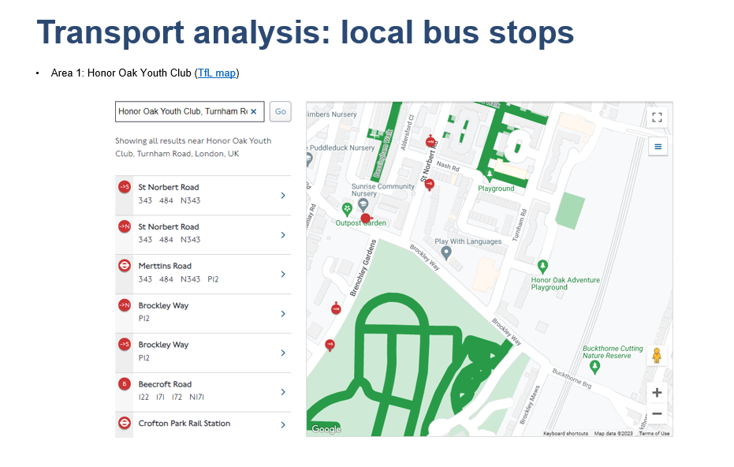

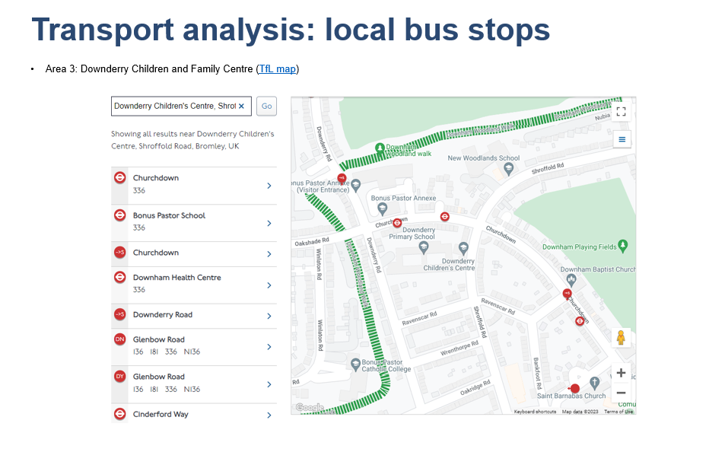

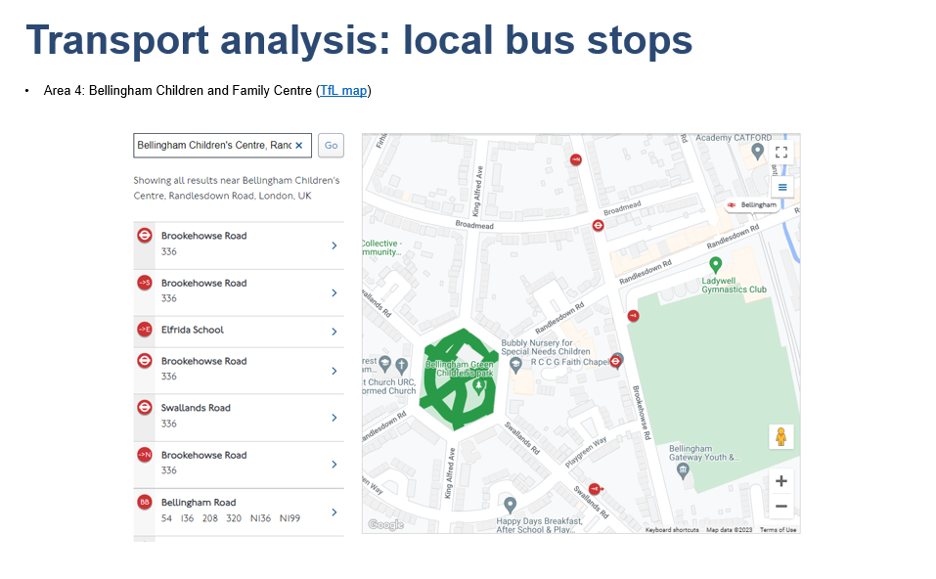

From the Equalities Analysis:

**Gender:**

There was disproportionality in gender in those accessing Children and Family Centres. More females accessed the Children and Family Centres than males. This could be partly because more mothers than fathers stop paid work or switch to part-time work while taking on the majority of the childcare.

The public consultation (May 2024) found that more fathers want to access services with their children and therefore more provision should be made available to / appeal to fathers.

**Age:**

Looking at registrations and contacts at Children and Family Centres and census data by age group, there was a variation in uptake and variability in delivery in the different Family Hub areas.

Area 1 has 24% of the 0-19 population 11% of the contacts

Area 2 has 29% of the 0-19 population 25% of the contacts

Area 3 has 26% of the 0-19 population 17% of the contacts

Area 4 has 22% of the 0-19 population 47% of the contacts

**Socio Economic:**

The registrations showed that most of the registration in Areas 1,3 and 4 were from the most deprived wards. This tallies with the IMD data which shows that 3 of the most deprived wards are in these areas.

**Disability:**

There is limited data on disability amongst children and young people. Disability data was not available from the EiSi system used by the Children and Family Centres. Recording of data on disability is often dependant on identification during a referral process. This will need to be improved with the new system.

**Ethnicity:**

Compared to the Census 2021 data the registrations for Children and Family Centres show there is some under representation in White British and White Irish populations and some over representation for White Other population. There is under representation for Black Caribbean, Black Other and Any Other Asian populations and over representation in Any Other Asian Background (as classified in the recording system – further analysis is required to understand more about the specific communities within the system classifications).

A look at contacts at Children and Family Centres shows that overall apart from Any Other Mixed Background and any Other Ethnic Group, contacts are less than the Census equivalent. This seems to be across contact types. However, there is some disproportionality in ethnicity in those accessing the Children and Family Centres for health-related sessions. The White British population accessing this service is equal to the Census data at 37% and any other White Background is 16% as opposed to 12% on the Census data. Apart from Any Other Mixed Background all other populations are underrepresented. In particular, Black African, Black Caribbean and Black Other are much less than the Census equivalent. As the BLACHIR report highlights Children and young people in Black ethnic groups have higher proportions of excess weight and low birth weight. The health-related sessions such as HENRY at Children and Family Centres directly support healthy eating and healthy lifestyles. More needs to be done to find out why these communities are not accessing this particular activity.

**Additional useful information**

The Assessment concluded that overall, there were no negative impacts to any protected characteristics as a result of their proposal, and in fact identifies overall positive impacts for residents accessing services.

The proposal to integrate the Early Childhood Offer into Family Hubs ensured that activities are monitored and services proactively engage with potential users of the service. The Family Hubs model has an outreach offer which continues this.

An integrated offer ensures there is a consistent offer across the borough and addresses the current inequity between the different areas.

A core purpose of Children and Family Centres (Early Childhood Offer) and Family Hubs is to reduce inequalities in outcomes for young children and their families in greatest need, including in the areas of child development, school readiness and parenting aspiration and skills. Family Hubs were set up having carried out a comprehensive needs analysis. Areas identified were obesity, substance misuse, domestic abuse, early language development, Special Educational Needs and Disabilities (SEND). This information was used initially to build a picture and identify sites and target services. This is a continuous process of the development of Family Hubs.

It is envisaged that there will be positive impacts across all protected characteristics as the proposal to integrate the Early Childhood Offer into the Family Hubs addresses the challenges that currently exist, particularly around access.

The new EHM and Groupworks system that Family Thrive and Family Hubs use to record usage and reach, will allow for real time data on attendance at sessions and show who is and is not accessing services. A signing in system will also be able to register user satisfaction. These systems will enable easy monitoring on who is accessing activities and how they feel about them by protected characteristic. This will allow for the service to address how it will reach those not accessing services and those not satisfied with services. This could include co-production, targeted publicity and outreach.

A key element of Family Hubs delivery is outreach and engagement which will directly address the barriers to accessing provision. Family Navigators work in the community going to where families are.

Family Hubs hold area meetings with partners on a quarterly basis to review data and discuss local needs and whether services are meeting those needs as their part of the continuous development. This will ensure a partnership approach to monitoring and delivering services.

**Community Assets maps**

Libraries:

1. Deptford Lounge
2. New Cross
3. Crofton Park
4. Lewisham
5. Manor House
6. Catford
7. Torridon Road
8. Forest Hill
9. Grove Park
10. Sydenham
11. Downham
12. Blackheath